Assignment 1

EXERCISE 1

Part 1
For both codes, all 2^{k} = 32 information vectors $v∈F_{2}^{5}$ were generated and encoded as c = vG (mod 2), and the Hamming weight of each codeword was computed. From these weights we obtained the multiplicities A_{i}=#{c $∈$ C : w_{H}(c) = i}, for i = 0,..., 10, reported in Table 1.

i | 0 | 1 | 2 | 3 | 4 | 5 | 6 | 7 | 8 | 9 | 10
A_{i} (code G₁) | 1 | 0 | 0 | 0 | 15 | 0 | 15 | 0 | 0 | 0 | 1
A_{i} (code G₂) | 1 | 0 | 0 | 2 | 9 | 9 | 6 | 4 | 0 | 1 | 0
Table 1:Weight distribution of the two codes

In both cases A₀ = 1, since the all-zero codeword is the only codeword of weight zero and belongs to every linear code. Moreover, $\sum_{i}{A_{i}}=32=2^{k}$, as expected from a one-to-one encoder.
Since both codes are linear, the minimum distance coincides with the minimum Hamming weight of the nonzero codewords, $d_{min}=\min_{c∈C, c≠0}{w_{H}\left(c\right)}$, so it is not necessary to compare all pairs of codewords. Therefore d_{min} is the smallest index i > 0 such that $A_{i}≠0$, and its multiplicity is A_{min} = A_{dmin}. The results are summarized in Table 2.

Code | d_{min} | A_{min}
G₁ | 4 | 15
G₂ | 3 | 2
Table 2: Minimum distance and its multiplicity

Part 2
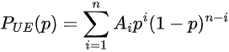
For a binary symmetric channel with crossover probability p, the probability of an undetected error is:

We evaluated this expression for both codes using the weight distributions of Table 1. Figure 1 shows the two curves on the same log–log axes for p $∈$ [10⁻⁶,10⁻¹].
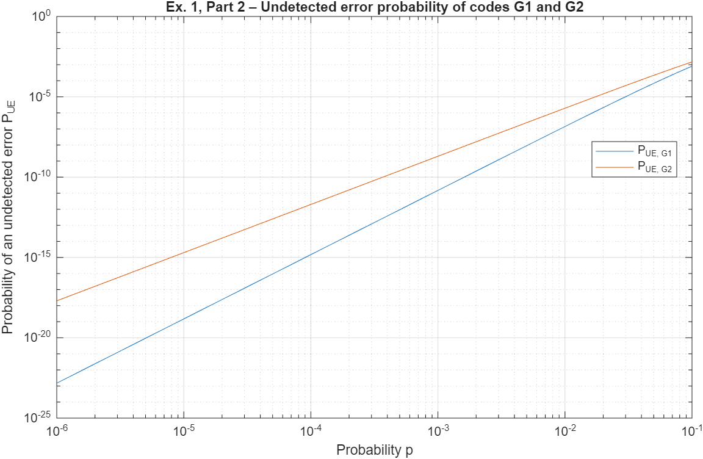

Figure 1
Since A_{i} = 0 for 0 < i < d_{min}, the first nonzero term of the sum is the one with i = d_{min}, whose coefficient is A_{dmin}=A_{min}:

For small p, each term with i > d_{min} is smaller than the first one by a factor of the order of p^{i-dmin}, which tends to zero, and (1-p)^{n-dmin}$≈$ 1. The leading term is therefore:

which gives P_{UE} $≈$15p⁴ for the first code and P_{UE} $≈$2p³ for the second one. Figure 2 compares the exact expressions with their leading terms.

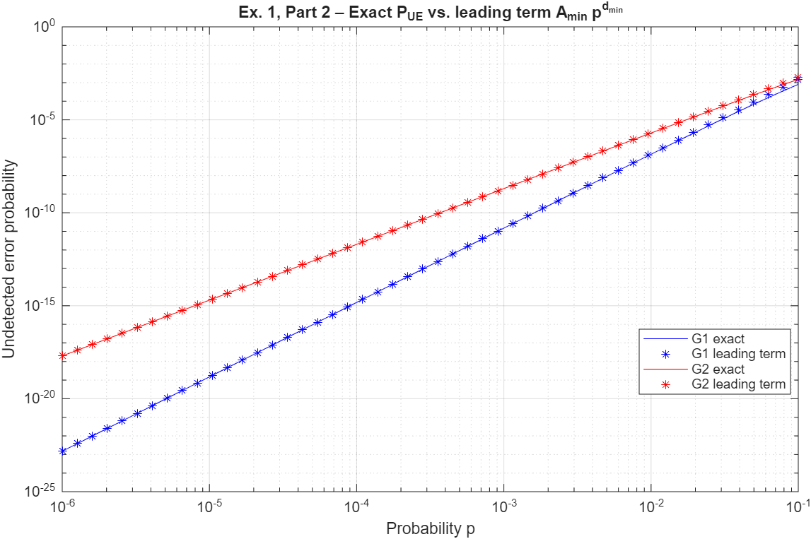

Figure 2
The approximation is very accurate for small p, while it slightly overestimates P_{UE} as p approaches 10⁻¹, where the factor (1-p)^{n-dmin} is no longer close to 1 (for the first code, 0.9⁶ $≈$ 0.53) and the higher-order terms are no longer negligible.
On log–log axes the leading term is a straight line, log P_{UE} $≈$log A_{min} + d_{min} log p. The two parameters therefore play different roles: d_{min} is the slope, while A_{min} is a multiplicative constant that shifts the curve vertically without changing its slope. A_{min} counts the error patterns of minimum weight that turn the transmitted codeword into another codeword.
The first code has better error-detection performance over the whole range of p. For example, at p = 10⁻³ we obtain P_{UE} $≈$1.5*10⁻¹¹ for the first code and P_{UE} $≈$ 2.0*10⁻⁹ for the second one. The reason is its larger minimum distance: d_{min} = 4 against d_{min} = 3, so its curve has slope 4 instead of 3, and the gap between the two codes grows as p decreases, reaching about five orders of magnitude at p = 10⁻⁶. The first code has a larger multiplicity (A_{min} = 15 against A_{min} = 2), but this only shifts the curve by a constant factor, while the different exponent dominates for small p. The gap shrinks as p increases and the leading-term approximation loses accuracy, but the first code remains better up to p = 10⁻¹.
This difference comes from a small change in the generator matrices: they differ only in the first row, and the first row of G₂ is itself a codeword of weight 3. Moreover, as observed in Part 1, all codewords of the first code have even weight, so every error pattern of odd weight is always detected, whereas the second code contains odd-weight codewords. Since both codes have the same n and k, and therefore the same rate, the first code achieves better protection at no additional cost in redundancy.

Part 3
The generator matrix of the first code is in systematic form, G₁ = [ I₅ | P], where P is the 5 x 5 matrix given by its last five columns. Following the convention of the lectures, the parity-check matrix is:
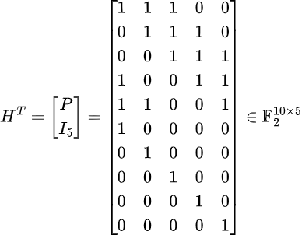

Each column of H^{T} corresponds to one parity-check equation, and the i-th row indicates in which equations the i-th codeword bit appears. As a check, we verified that G₁ H^{T} = 0: every row of G₁ is a codeword and satisfies all the parity-check equations.
We chose:
y₁ = (0,1,0,0,1,1,0,1,1,1) and y₂ = (0,1,0,0,1,1,0,1,1,0).
y₁ is a codeword: it is obtained by encoding the information vector v = (0,1,0,0,1). Since a vector has zero syndrome if and only if it is a codeword, its syndrome is s₁ = y₁ H^{T} = (0,0,0,0,0). y₂ is obtained from y₁ by flipping the last bit. Its syndrome is
s₂ = y₂ H^{T} = y₁ H^{T} + e H^{T} = e H^{T} = (0,0,0,0,1)$≠$0
which is the 10th row of H^{T}: a single error in position i produces as syndrome the i-th row of H^{T}. More generally, every error of weight 1 is detected, because the code has d_{min} = 4 and no nonzero codeword has weight smaller than 4.
The parity-check matrix of a code is not unique. We built
where U is the 5 x 5 permutation matrix that swaps the first and the fifth column. Since U is invertible,
so a vector has zero syndrome with respect to $H_{1}^{T}$ if and only if it is a codeword. The resulting matrix is
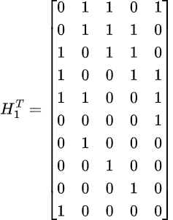

and the syndromes of the two vectors are s₁ = (0,0,0,0,0) and s₂ = (1,0,0,0,0). The value of the nonzero syndrome changes (its bits are permuted), but whether the syndrome is zero or not does not depend on the chosen parity-check matrix.
We built $H_{2}^{T}$by appending to $H_{1}^{T}$ two additional columns, equal to its first two columns:

where h₁ and h₂ are the first two columns of $H_{1}^{T}.$
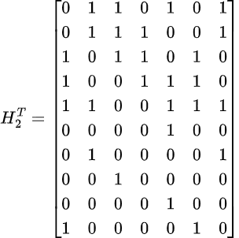

The two new columns correspond to two redundant parity-check equations, already contained in $H_{1}^{T}$. If y$H_{1}^{T}$=0, the two additional syndrome bits are also zero; conversely, if y$H_{2}^{T}$= 0, its first five bits give y$H_{1}^{T}$= 0. Therefore y$H_{2}^{T}$= 0 if and only if y is a codeword. The rank of $H_{2 }^{T}$is still 5, so the seven equations describe the same code. The syndromes are s₁ = (0,0,0,0,0,0,0) and s₂ = (1,0,0,0,0,1,0).

Part 4
For the first code and for each value of p $∈$ {0.10, 0.09, 0.08, 0.07, 0.06}, we repeatedly generated a random information vector, encoded it, transmitted the codeword over a BSC with crossover probability p, and computed the syndrome of the received vector. An undetected error was counted whenever the syndrome was zero but the received vector differed from the transmitted codeword. The simulation was stopped after 10 undetected errors, and then repeated independently with a stopping criterion of 100 undetected errors. In both cases P_{UE} was estimated as the number of undetected errors divided by the total number of transmitted codewords. The random generator was initialized with a fixed seed, so that the results are reproducible.
Figure 3 shows the two Monte Carlo estimates of P_{UE}, obtained with 10 and 100 undetected errors, together with the analytical expression derived in Part 2, as a function of the crossover probability p. The analytical curve is the reference value: since it is computed from the exact weight distribution of the code, it contains no statistical uncertainty. The distance between each simulated point and the analytical curve therefore measures the error of the corresponding Monte Carlo estimate. The same values are reported numerically in Table 3, which makes the comparison at each value of p easier.
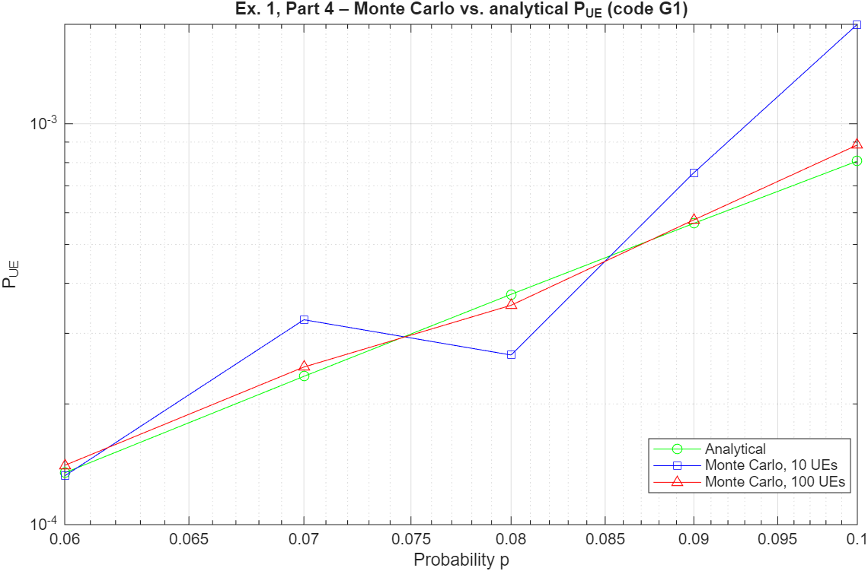

Figure 3
p | Analytical | Monte Carlo, 10 UEs | Monte Carlo, 100 UEs
0.10 | 8.07*10⁻⁴ | 1.77*10-3 | 8.85*10-4
0.09 | 5.64*10⁻⁴ | 7.54*10-4 | 5.75*10-4
0.08 | 3.75*10⁻⁴ | 2.65*10-4 | 3.52*10-4
0.07 | 2.34*10⁻⁴ | 3.24*10-4 | 2.47*10-4
0.06 | 1.35*10⁻⁴ | 1.32*10-4 | 1.40*10-4

Table 3
A Monte Carlo estimate is a random variable: running the same simulation with a different seed gives a different value. A confidence interval is a range of values, computed from the simulation results, built so that it contains the true value of the estimated quantity with a given probability, called the confidence level (typically 95%). In other words, if the simulation were repeated many times, about 95% of the intervals obtained in this way would contain the true P_{UE}. When the simulation is stopped after N undetected errors, the relative standard deviation of the estimate ${\overset{ˆ}{P}}_{UE}$ is approximately $1/\sqrt{N}$, and an approximate 95% confidence interval is
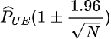

For N = 10 this gives a relative uncertainty of about $±$62%, for N = 100 about $±$20%. Confidence intervals can be used to assess the reliability of the estimates in two ways: to check whether the deviation from the analytical value is compatible with statistical fluctuations, and to decide in advance how many undetected errors are needed to reach a target accuracy.
The estimates obtained with 10 undetected errors show large fluctuations around the analytical curve, while those obtained with 100 undetected errors are significantly closer to it. This is consistent with the expected relative uncertainty, which decreases as $1/\sqrt{N}$: increasing the number of counted events by a factor of 10 reduces the uncertainty by a factor of about 3. Overall, the simulated values agree with the analytical expression within the statistical uncertainty, which confirms both the correctness of the analytical model and of the simulator.
The price of a higher accuracy is the simulation time. The expected number of transmissions needed to observe N undetected errors is about N/P_{UE}: for N = 100 it ranges from about 1.2*10⁵ at p = 0.10 to 7.4*10⁵ at p=0.06. Halving the confidence interval requires four times more events, and therefore four times more transmissions. Moreover, the simulation time grows very quickly as p decreases, because P_{UE} decreases as p^{dmin} =p⁴: at p=10⁻³, where P_{UE} $≈$ 1.5*10⁻¹¹, about 7*10¹² transmissions would be needed to observe 100 undetected errors, which is not feasible. This is why the simulation was limited to relatively large values of p.
This shows the advantages of having an analytical expression for P_{UE}: it gives exact values with no statistical uncertainty, it is evaluated instantaneously for any value of p, including the very small values of practical interest that cannot be reached by simulation, and it shows explicitly how the performance depends on the code parameters (d_{min}, A_{min} and the whole weight distribution). Monte Carlo simulation remains useful to validate the analytical model and to study systems for which no closed-form expression is available.

Part 5
We consider an ideal ARQ protocol for the first code: each transmission attempt is independent and takes place over the same BSC; a received vector with nonzero syndrome is rejected and, if allowed, the same codeword is retransmitted; a received vector with zero syndrome is accepted; after at most i attempts the procedure stops, and if the last attempt is rejected the block is lost.
A single transmission has exactly one of three outcomes, which are mutually exclusive and exhaustive. To compute their probabilities, recall that the received vector is y = c + e, and that on a memoryless BSC an error vector of Hamming weight w has probability:
since each of the w flipped bits contributes a factor p and each of the n-w correct bits a factor 1-p.
- correct reception. The received vector equals the transmitted codeword only if e = 0, which has weight 0. Therefore:

- undetected error. The syndrome is s = yH^{T} = eH^{T}, so it is zero if and only if e is a codeword. An undetected error occurs when e is a nonzero codeword. Summing the probabilities of all nonzero codewords, and grouping them by weight (there are A_{j} codewords of weight j, each with probability p^{j}(1-p)^{n-j}, and none with weight 0 < j < d_{min}), we obtain:
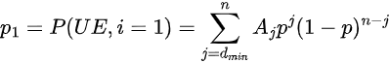

- rejection. A block is rejected when e is not a codeword. Since the three outcomes are mutually exclusive and exhaustive, p₀ + p₁ + p₂ = 1, and:

For the first code, with n = 10 and the weight distribution of Table 1:
p₀=(1-p)¹⁰ p1=15p⁴(1-p)⁶+15p⁶(1-p)⁴+p¹⁰ p₂=1-p₀-p₁
The block is received correctly at the (j+1)-th attempt if the first j attempts are rejected and the (j+1)-th one is correct. Since the attempts are independent, this sequence has probability p₂^{j}p₀. These events are mutually exclusive for different j, so with at most i attempts
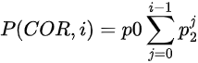

which gives:
- P(COR, 0) = p₀;
- P(COR, 1) = p₀(1+p₂);
- P(COR, 2) = p₀(1+p₂+p₂²);

Figure 4 shows 1 - P(COR, i) for i = 1, 2, 3 as a function of p, for 10⁻² $≤$p $≤$10⁻¹. This quantity is the probability that the block is not received correctly, either because an undetected error occurs or because all the allowed attempts are rejected.

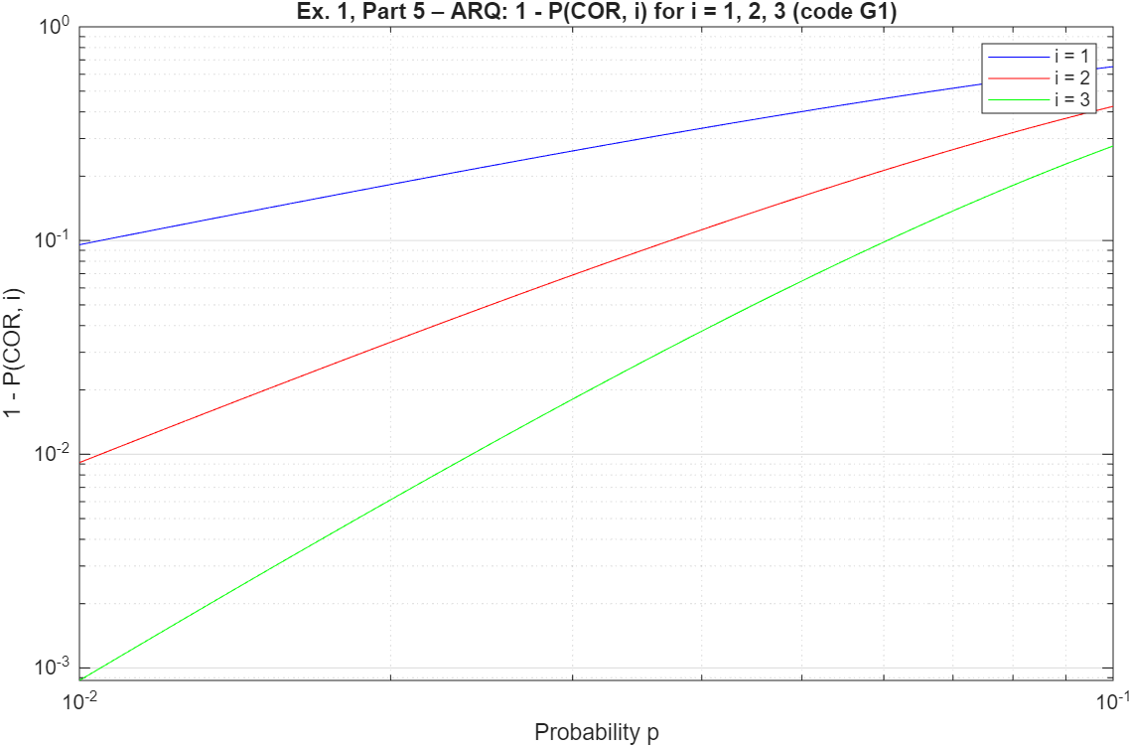

Figure 4

Each additional attempt significantly reduces the probability of failure: at p = 10⁻² it goes from about 9.6*10⁻² with a single attempt to 9.1*10⁻³ with two and 8.7*10⁻⁴ with three. On the log–log axes the three curves have slopes close to 1, 2 and 3 for small p. Indeed, in this range p₁ is negligible and the failures are almost entirely due to rejections, so 1 - P(COR, i) $≈$ p₂^{i}, with p₂ $≈$1 - (1-p)^{n} $≈$np: each additional attempt multiplies the failure probability by approximately p₂. The improvement becomes smaller as p increases: at p=10⁻¹ a single transmission is rejected with probability p₂ $≈$0.65, and the failure probability only decreases from about 0.65 to 0.42 and 0.28.

Part 6
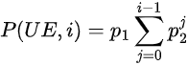
We use the notation of Part 5: in a single attempt the block is received correctly with probability p₀, contains an undetected error with probability p₁, and is rejected with probability p₂. With at most i attempts, the same reasoning used for P(COR, i) gives the probability of an undetected error:

since an undetected error occurs at the (j+1)-th attempt if the first j attempts are rejected and the (j+1)-th one is accepted although wrong.
Do more attempts increase the probability of correct reception? Yes. Going from i to i+1 attempts adds the nonnegative term p₀p₂^{i}:

so P(COR, i) increases with i, as also shown in Figure 4. The improvement is large when p₂ is large, and becomes smaller at each additional attempt, since p₂^{i} decreases geometrically. As i $∞$, using the geometric series,
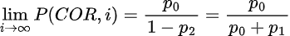

This limit is smaller than 1: even with an unlimited number of attempts, correct reception is not guaranteed, because an attempt can be accepted with an undetected error. For the first code, it is about 1 - 1.6*10⁻⁷ at p=10⁻² and about 0.9977 at p = 10⁻¹.
Can retransmissions eliminate undetected errors? No. A retransmission is requested only when the syndrome is nonzero (when the receiver knows that the block is wrong). An undetected error produces a zero syndrome, so the block is accepted and never retransmitted. Moreover, every additional attempt is a new opportunity for an undetected error, so P(UE, i) also increases with i: at p = 10⁻¹ it goes from 8.1*10⁻⁴ with i = 1 to 1.3*10⁻³ with i = 2 and 1.7*10⁻³ with i = 3, up to the limit p₁/(p₀+p₁) $≈$2.3*10⁻³ for i $∞$. Undetected errors depend only on the code and on the channel: they can only be reduced by using a code with better detection capability (larger d_{min} and smaller A_{min}).
Allowing more attempts increases the probability of correct reception, but each retransmission costs time and channel resources. The receiver must detect the error, send a retransmission request over the return link, and wait for the new block, so each attempt adds at least one round-trip time to the delivery delay. Retransmissions also occupy channel resources that could be used for new data, which reduces the effective throughput, and they require the transmitter to store the block until it is acknowledged. The maximum number of attempts must therefore be chosen according to the application: delay-tolerant services can afford many attempts, while delay-sensitive services can allow only a few, or none. When the round-trip time is very long, as in deep-space links, retransmissions become impractical and error correction is preferred.
Let N be the number of transmissions actually performed with at most i attempts. The procedure stops at attempt j < i if the first j-1 attempts are rejected and the j-th one is accepted (correctly or not), while it reaches attempt i whenever the first i-1 attempts are rejected, whatever the outcome of the last one:
P(N=j) = p₂^{j-1}(1-p₂) (1$≤$ j < i ), P(N=i) = p₂^{i-1}
- i=1: one transmission is always performed, so E[N]=1.
- i=2: P(N=1) = 1-p₂, P(N=2) = p₂, so
E[N] = 1*(1-p₂)+2p₂=1+p₂.
- i=3: P(N=1) = 1-p₂, P(N=2) = p₂(1-p₂), P(N=3) = p₂², so
E[N] = (1-p₂)+2p₂(1-p₂)+3p₂² = 1+p₂+p₂².

To generalize, note that N $≥$j if and only if the first j-1 attempts are rejected, so P(N $≥$j) = p₂^{j-1} for 1 $≤$j $≤$i. Since for a random variable taking positive integer values E[N]$=\sum_{j≥1}{P}\left(N≥j\right)$,
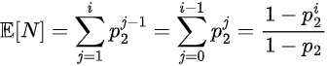

which agrees with the three cases above. As i $∞,$since p₂ < 1,
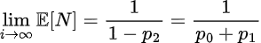

The average number of transmissions remains finite even without a limit on the number of attempts: it is close to 1 when the channel is good, and grows as the channel gets worse.
p | p₂ | i=1 | i=2 | i=3 | i $∞$
10-2 | 0.096 | 1 | 1.096 | 1.105 | 1.106
10-1 | 0.651 | 1 | 1.651 | 2.074 | 2.861
Table 4: Expected number of E[N] for the first code

At p = 10⁻² retransmissions are rarely needed and E[N] stays close to 1, while at p = 10⁻¹ almost three transmissions per block are needed on average for i $∞$, so the effective throughput is reduced by almost a factor of 3. Note also that P(COR, i) = p₀E[N]: each transmission performed is a new chance of correct reception, with probability p₀.
A block is accepted if it is received either correctly or with an undetected error. The probability of an undetected error, conditioned on the acceptance of the block, is therefore:

where the common factor $\sum_{j=0}^{i-1}{p_{2}^{ j}}>0$cancels. The result does not depend on i. For the first code it is about 1.6*10⁻⁷ at p = 10⁻² and 2.3*10⁻³ at p = 10⁻¹.
The meaning is that retransmissions do not change the quality of the accepted blocks. Whatever the attempt at which a block is accepted, the acceptance happens in a single transmission, where the probability of being correct is proportional to p₀ and that of being wrong to p₁. Additional attempts only turn some of the blocks that would have been lost into accepted blocks, keeping the same proportion between correct and wrong ones. In other words, ARQ improves the probability of delivering a block, but the reliability of the delivered blocks is determined only by the code and the channel.

EXERCISE 2

We chose the primitive polynomial of degree r = 4:
p(D) = D⁴ + D + 1,
taken from the table of primitive polynomials.
The generator polynomial is
g(D) = (D + 1)p(D) = D⁵ + D⁴ + D² + D + D + 1 = D⁵ + D⁴ + D² + 1,
where the two terms in D cancel since D + D = 0 over F₂. Since deg g(D) = r + 1 = 5, each codeword contains 5 parity bits and has length n = k + 5.
The four information vectors were encoded systematically: v(D) is multiplied by D^{r+1} = D⁵, and the remainder of the division by g(D) is added, so that the first k bits of the codeword are the information bits and every codeword is a multiple of g(D). The results are reported in Table 5.
v | v(D) | c(D) | c | w_{H}(c)
00 | 0 | 0 | 0000000 | 0
01 | 1 | D⁵+D⁴+D²+1 | 0110101 | 4
10 | D | D⁶+D⁴+D³+D²+D+1 | 1011111 | 6
11 | D+1 | D⁶+D⁵+D³+D | 1101010 | 4
Table 5: Systematic encoding with g(D) = D⁵ + D⁴ + D² + 1 for k = 2 (n = 7)
The weight distribution for k = 2 is A₀ = 1, A₄ = 2, A₆ = 1, and A_{i} = 0 for all other values of i. As expected, $\sum_{i}{A_{i}}=4=2^{k}$.
The minimum Hamming weight of the nonzero codewords is 4, so d_{min} = 4, and all codewords have even weight. Both properties follow from the structure of g(D):
- Even weights Every codeword is a multiple of g(D), c(D) = q(D)g(D), and g(1) = 1 + 1 + 1 + 1=0. Therefore c(1) = q(1)g(1) = 0. Since c(1) is the sum of the bits of c modulo 2, every codeword contains an even number of ones. This is the effect of the factor D + 1.
- No codewords of weight 2 A weight-2 codeword would be a polynomial D^{i} + D^{j} divisible by g(D), and hence by the primitive factor p(D). As discussed in the explanation below, this is impossible for such a short codeword length.

Since all odd weights are excluded, and weight 2 is excluded too, the smallest possible nonzero weight is 4. Note also that the codeword of v = 01 coincides with g(D) itself, which is the lowest-degree nonzero multiple of g(D).

We increased k by one and repeated the procedure until codewords of weight 2 appeared, which happened for k = 11. The weight distributions are reported in Table 6. Only even weights are shown, since Ai = 0 for every odd i and every value of k.

k | n | d_{min} | A₀ | A₂ | A₄ | A₆ | A₈ | A₁₀ | A₁₂ | A₁₄ | A₁₆
2 | 7 | 4 | 1 | 0 | 2 | 1 | 0 | 0 | 0 | 0 | 0
3 | 8 | 4 | 1 | 0 | 5 | 2 | 0 | 0 | 0 | 0 | 0
4 | 9 | 4 | 1 | 0 | 10 | 4 | 1 | 0 | 0 | 0 | 0
5 | 10 | 4 | 1 | 0 | 16 | 12 | 3 | 0 | 0 | 0 | 0
6 | 11 | 4 | 1 | 0 | 25 | 27 | 10 | 1 | 0 | 0 | 0
7 | 12 | 4 | 1 | 0 | 38 | 52 | 33 | 4 | 0 | 0 | 0
8 | 13 | 4 | 1 | 0 | 55 | 96 | 87 | 16 | 1 | 0 | 0
9 | 14 | 4 | 1 | 0 | 77 | 168 | 203 | 56 | 7 | 0 | 0
10 | 15 | 4 | 1 | 0 | 105 | 280 | 435 | 168 | 35 | 0 | 0
11 | 16 | 2 | 1 | 1 | 133 | 469 | 835 | 483 | 119 | 7 | 0
Table 6: Weight distribution coefficients Ai for k = 2,…,11
For every k the coefficients sum to 2^{k}, and all codewords have even weight, since the factor D + 1 is present for every k. For 2 $≤$ k $≤$10 the minimum distance is d_{min} = 4: the code detects all error patterns of weight 1, 2 and 3. As k grows, the number of codewords grows as 2^{k}, and so does the number A₄ of codewords at minimum distance, which increases the probability of an undetected error. For k = 11 a single codeword of weight 2 appears, c(D) = D¹⁵ + 1 and the minimum distance drops to d_{min} = 2.
A weight-2 codeword is a polynomial e(D) = D^{i} + D^{j}, with n - 1 $≥$i > j $≥$0, which is a multiple of g(D)=(D+1)p(D). Since D + 1 and p(D) are distinct irreducible polynomials, g(D) divides e(D) if and only if both D + 1 and p(D) divide it.
- Factor D + 1 We have e(1) = 1 + 1 = 0, so every weight-2 polynomial is divisible by D + 1. This factor never excludes weight-2 codewords.
- Factor p(D) We can write e(D) = D^{j}(D^{i-j} + 1). Since p(0) = 1, p(D) has no factor in common with D^{j}, so p(D) divides e(D) if and only if it divides D^{i-j} + 1.
- Primitivity Since p(D) is primitive of degree r = 4, the smallest b $≥$ 1 such that p(D) divides D^{b} + 1 is b = 2^{r} - 1 = 15. Hence a weight-2 codeword requires i - j $≥$15.
- Codeword length In a codeword of length n the two nonzero positions satisfy i - j $≤$n - 1$. Therefore weight-2 codewords exist if and only if n - 1 $≥$15.

Since n = k + r + 1 = k + 5, the condition n $≥$ 16 becomes k $≥$11$. For k $≤$10 we have n $≤$15 = 2^{r} - 1, which is exactly the condition under which a CRC with a primitive factor of degree r detects all weight-2 error patterns. For k = 11, n = 16 and the only pair of positions at distance 15 is i = 15, j = 0, which gives the single weight-2 codeword D¹⁵ + 1, in agreement with A₂ = 1 in Table 6. In general, with a primitive polynomial of degree r, weight-2 codewords first appear for k = 2^{r} – r – 1.

